CS 255 System Design Document

UML Diagrams

UML Use Case Diagram
This diagram identifies the six roles and gates every protected action behind login.

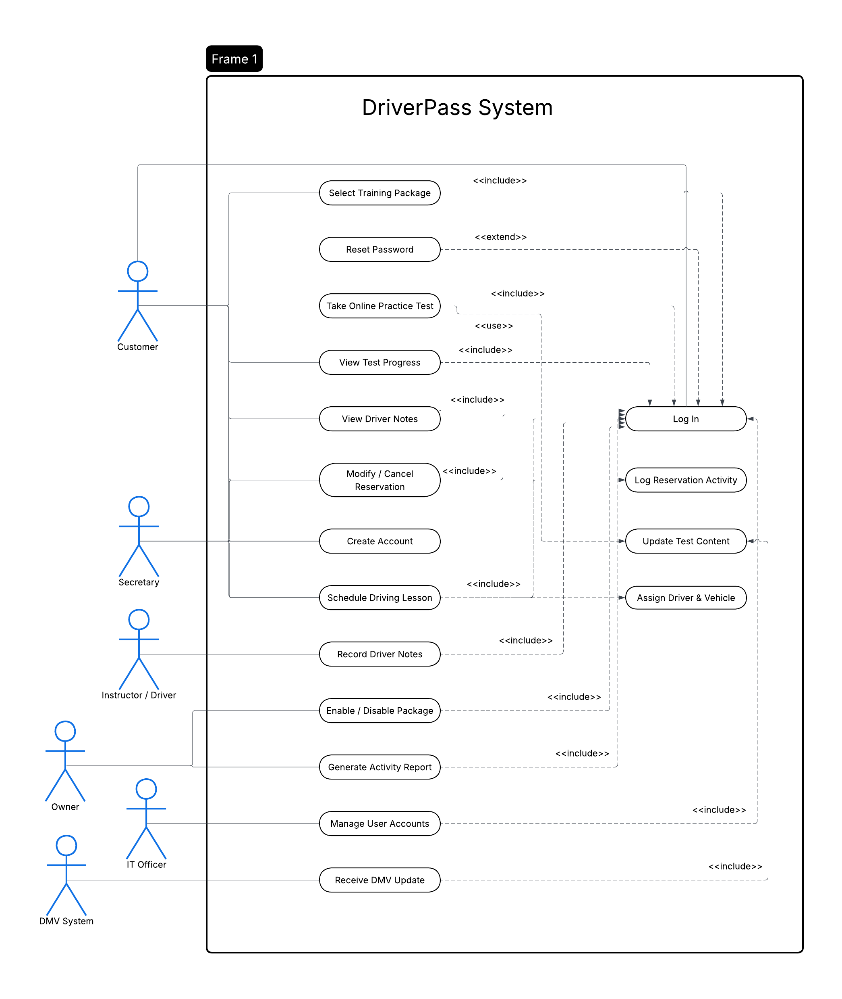

UML Activity Diagrams
These are two activity diagrams that show a step-by-step flow of two important use cases: Scheduling a driving lesson and taking an online practice test.

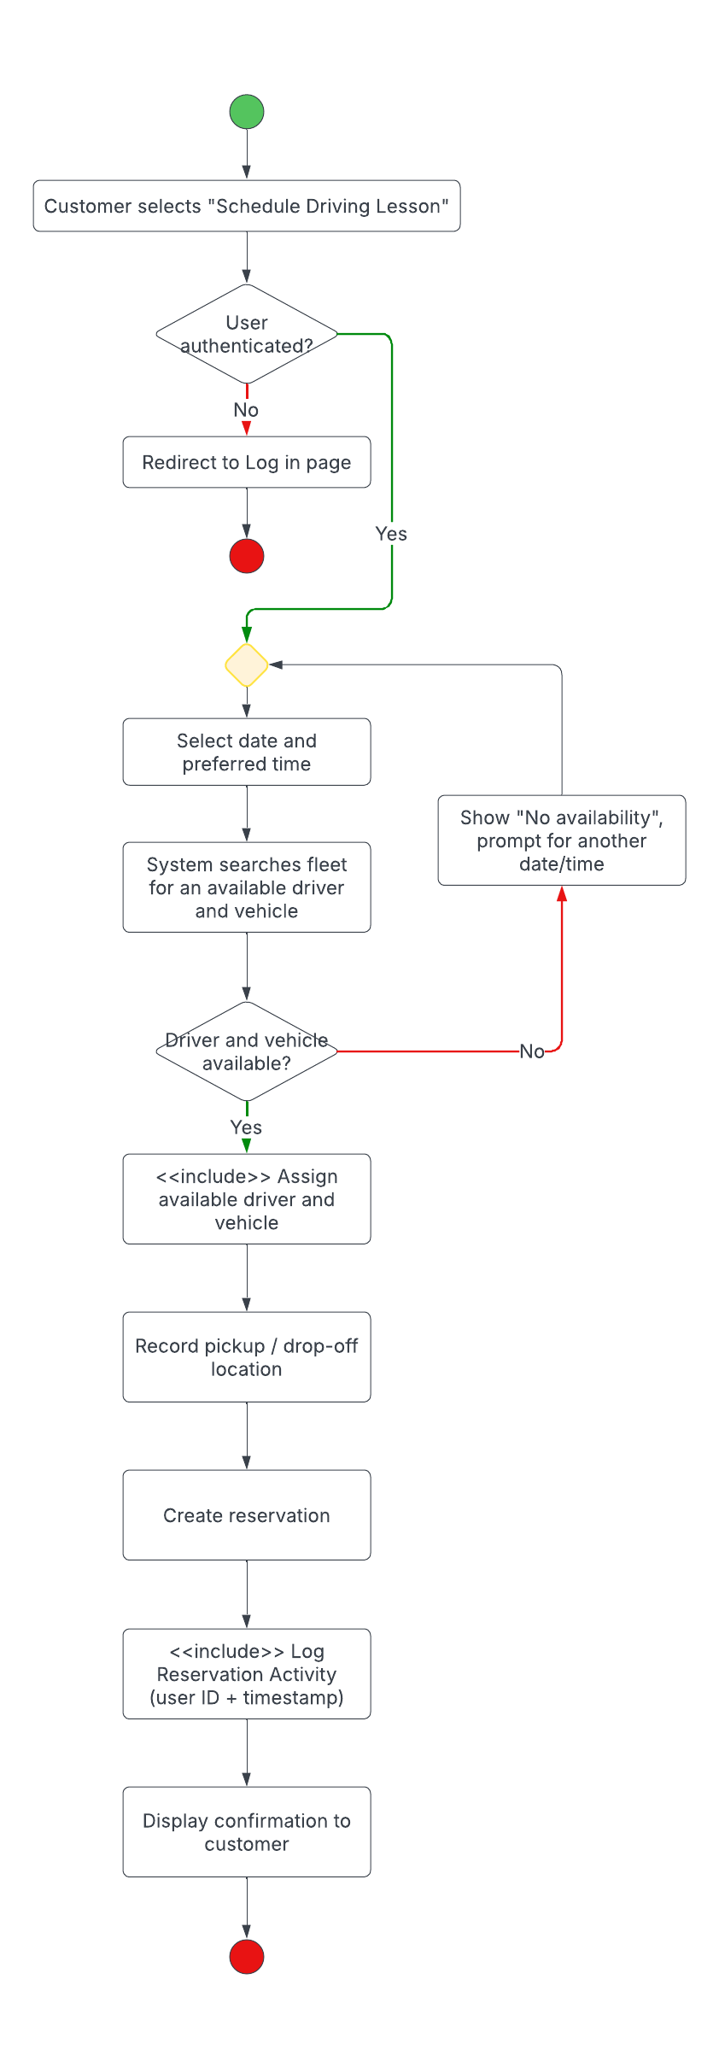
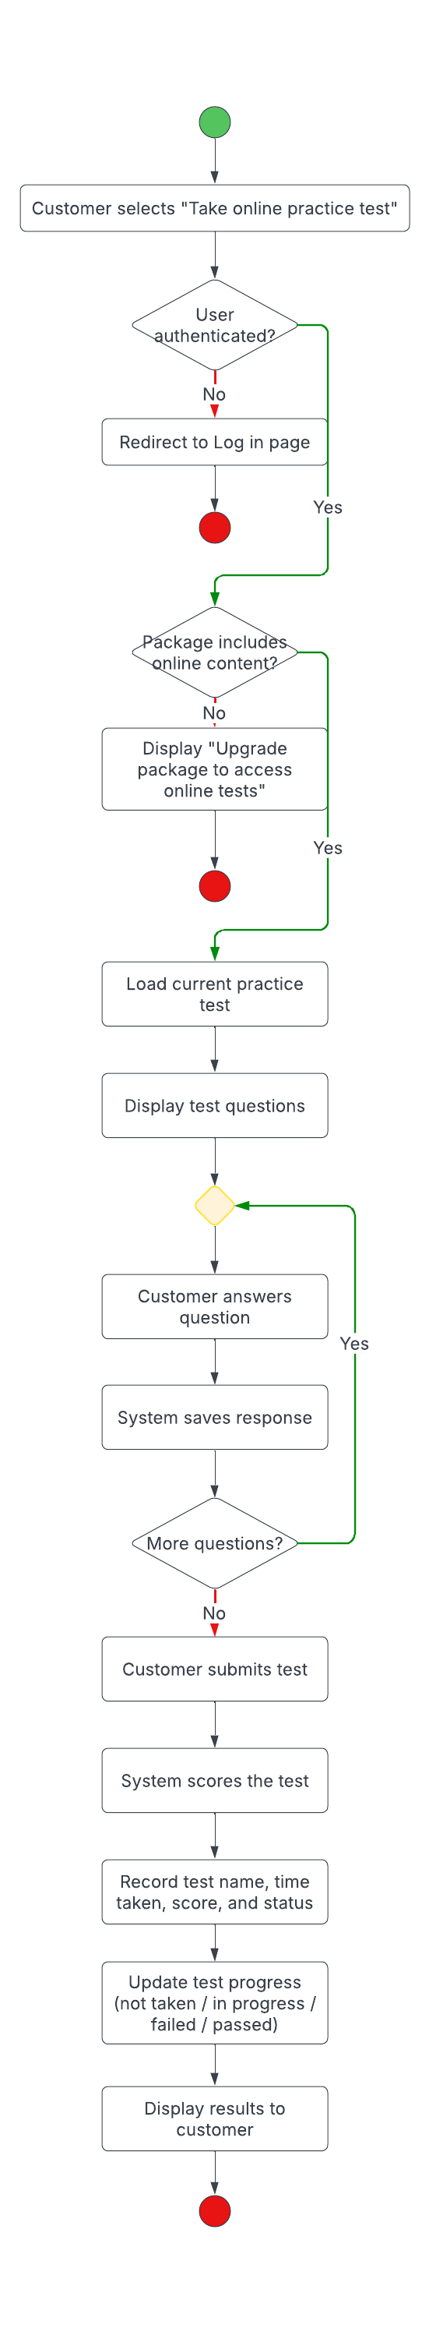

UML Sequence Diagram
This is a UML Sequence Diagram based off of scheduling a driving lesson.
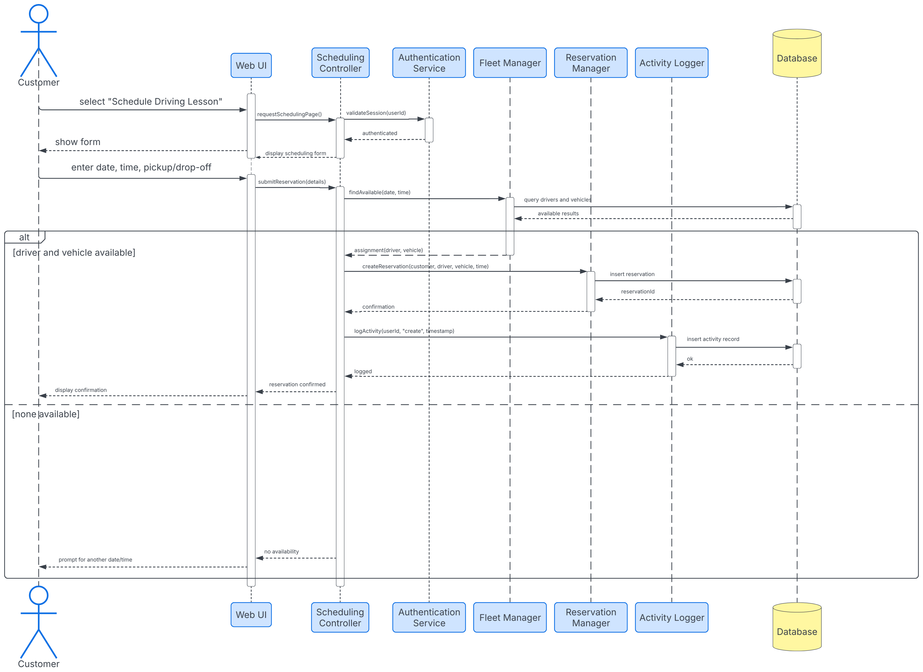

UML Class Diagram
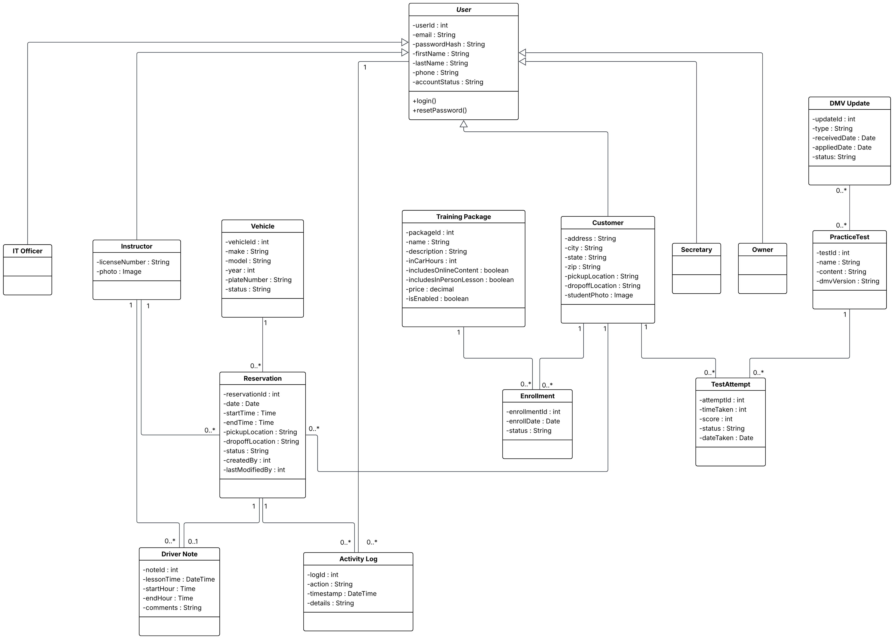

Technical Requirements
Infrastructure and Hardware
- Cloud hosting: The system is hosted with a cloud provider such as Amazon Web Services, so that DriverPass staff are not responsible for server maintenance, backups, failover, or security.
- Application tier: Load-balanced web and application server instances run the DriverPass web application and its REST API. This allows the system to scale horizontally and support many concurrent users without having to worry about any system degrading or performance loss.
- Database tier: A managed relational database instance, with automated daily backups and failover stores all persistent data.
- Client hardware: Any desktop, laptop, tablet, or smartphone with a web browser and an internet connection can access the system. No specialized hardware is required.

Operating Systems and Platforms
- Server side: The application and database servers run on a stable Linux distribution, managed by the cloud provider.
- Client side: Being as the system is fully web-based, you can use any of the following operating systems: Windows 10/11, macOS, ChromeOS, Apple iOS, and Android. It will have a responsive interface that adapts to any device with varying screen sizes.

Supported Web Browsers
- The supported web browsers will be Google Chrome, Mozilla Firefox, Microsoft Edge, and Apple Safari.

Software and Frameworks
- Front end: A responsive web application built with HTML5, CSS3, and a JavaScript framework, such as React, delivering varying pages such as a dashboard, scheduling pages, and practice test interfaces.
- Back end: A server-side application framework, such as Node.js with Express, or ASP.NET Core) exposing a REST API, that is secured, and contains the business logic for authentication, scheduling, fleet assignment, testing, reporting, and role management.
- Database management system: PostgreSQL, stores user accounts, training packages, enrollments, reservations, vehicles, driver notes, practice tests and results, audit logs, and DMV update records.
- Reporting and export: A reporting module generates printable activity reports and exports data in Excel-compatible formats.

Security
- All traffic between the client and the server is encrypted using HTTPS with TLS 1.2.
- Passwords are never stored in plain text, they will be hashed with an algorithm such as bcrypt.
- Role-based access control ensures each user type can only reach the functions appropriate to their role.
- Brute-force protection: To protect against brute-force password attempts, after five consecutive failed attempts on an account within a short window, the account will be locked and the IT officer is automatically notified.
- Customers can reset their own password through a secure password reset link, that will be time-limited, and a one-time use, sent directly to their email.

Integrations and Tools
- DMV integration: A secure REST/API integration with the DMV receives notifications of new rules, policies, and sample questions. The new update will be applied to the practice-test within an applicable timeframe, such as 24 hours from the time of the notification.
- Email service: A transactional email service handles password-reset links and system notifications.
- Monitoring and logging: Application and infrastructure monitoring tools track uptime, errors, and performance.
- Design and version control: I created UML models in Lucidchart of the current designs, which are the base and first-version of the designs as originally discussed. The source code can be managed in a Git repository for version control and to support a collaborative environment across a team of developers.

Performance
- Core pages login, dashboard, scheduling, and tests should load very quickly, like 3 seconds under normal conditions.
- The system supports multiple concurrent users without degraded performance. Data may be created or modified while the system remains available online, while offline access is read-only to prevent data redundancy.

